Q01. Which categories generate the highest revenue and margin?

Finding
Based on the category-level aggregation from the NexusMart data warehouse, Electronics generated the highest net revenue and margin amount among the listed categories.
- Net revenue: PKR 73,504,799.94 (approximately PKR 73.50 million).
- Margin amount: PKR 18,586,396.94 (approximately PKR 18.59 million).
Fashion ranked second in net revenue at PKR 37,841,063.51 and generated a margin amount of PKR 18,297,679.51. Home & Kitchen generated PKR 26,882,277.54 in net revenue and PKR 9,920,553.67 in margin amount.

Interpretation
Electronics is the strongest category by absolute net revenue and margin amount in this query. Fashion's margin amount is close to Electronics' despite its substantially lower net revenue. This suggests that margin percentage may differ considerably across categories, so absolute margin alone should not determine which category is most profitable relative to sales.

Recommendation
Prioritize Electronics when evaluating opportunities to grow revenue and margin. Investigate Fashion's cost structure, discounts, and returns to understand why it generates a similar absolute margin on lower net revenue. Calculate margin percentage by category before making further profitability decisions.

Method and evidence
The analysis grouped FactSales by DimProduct category and calculated gross sales, NMV, valid refunds, net revenue, cost of goods on kept lines, and margin amount. The full SQL results screenshot and the Unknown-product diagnostic screenshots are retained as supporting evidence.
Validation limitation: The margin calculation assumes the warehouse's IsReturned flag correctly identifies lines with valid returns. The return classification and kept-line logic should be validated before treating margin as final.
Evidence files:
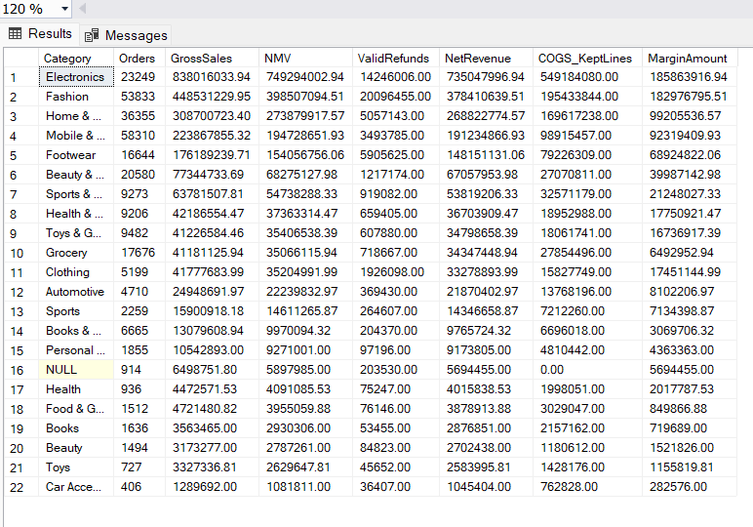

Data-quality note
The results contain a NULL category associated with the warehouse's Unknown product member (ProductKey = 0). A separate diagnostic found 918 fact rows representing 918 distinct order items, 3,055 units, and PKR 6,184,782.80 in merchandise value. The Unknown dimension member is labelled UNKNOWN / Unknown Product, with a NULL category.
These records cannot currently be attributed to a named product category with confidence. They should remain identifiable as unknown until the original product references are investigated. The reported category comparison should therefore be interpreted with this limitation in mind.
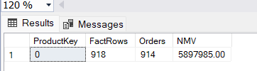
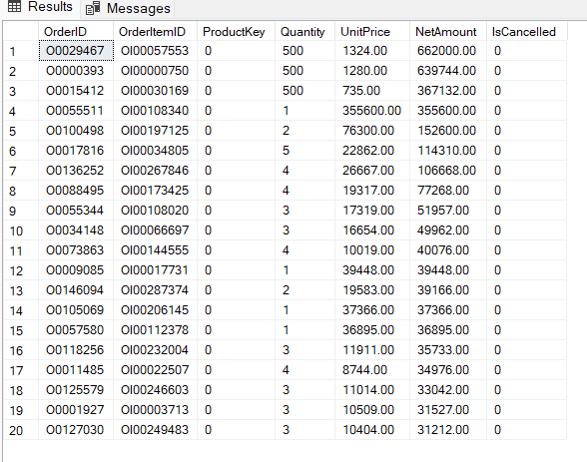
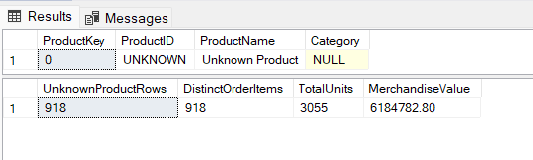

Q02. Which provinces and cities contribute the most and least sales? What share comes from the top five cities?

Province-level findings
The latest analytical query, which combines the province aliases identified in the warehouse results, ranks Punjab first, with net revenue of PKR 85.96 million. Sindh ranks second at PKR 51.08 million, followed by Khyber Pakhtunkhwa at PKR 25.19 million.
The query also returns an Unknown province group with net revenue of approximately PKR 20.64 million. These records remain separate because their province cannot be confidently assigned from the current labels.

Interpretation
Punjab is the leading province by net revenue in the normalized query results. This indicates that it is an important region for sales and revenue analysis. However, the Unknown group is material and should be considered when interpreting the geographic distribution of sales.

Recommendation
Prioritize Punjab when evaluating regional growth opportunities. Compare regional delivery performance, returns, and cancellations before deciding where operational improvements may have the greatest impact.

Data-quality and methodology note
The source dimension contains inconsistent province labels, including spelling and naming variants. The analysis combines identified aliases at query level without modifying the underlying warehouse. Consequently, the reported ranking reflects the labels normalized by this query, not proof that every location record has been standardized. Unknown province records are retained separately rather than assigned without evidence.

Evidence
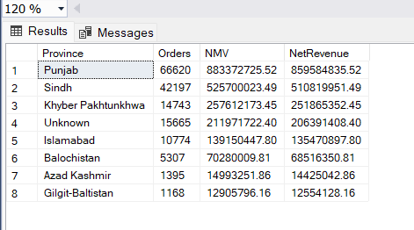

Q03. How does monthly revenue change, and what is the month-over-month growth?
Finding: Monthly net revenue fluctuated throughout January 2024–June 2025. The strongest positive month-over-month growth in the results was November 2024 (+51.50%). The sharpest decline was April 2025 (−39.85%). The highest net revenue in the displayed period was June 2025, at approximately PKR 149.25 million.
Interpretation: Revenue growth was uneven rather than consistently increasing. November's increase and April's decline warrant further investigation against order volumes, category mix, discounts, returns, and seasonal events. The trend alone does not establish what caused these changes.
Recommendation: Monitor month-over-month net revenue alongside NMV, refunds, order counts, and margin. Investigate the drivers of the November 2024 increase and April 2025 decline before making promotional or inventory decisions.
Method: Monthly NMV was calculated from non-cancelled order lines. Net revenue was calculated as NMV minus the warehouse's valid-refund amount. Month-over-month growth compares current-month net revenue with the preceding month's net revenue.
Evidence:
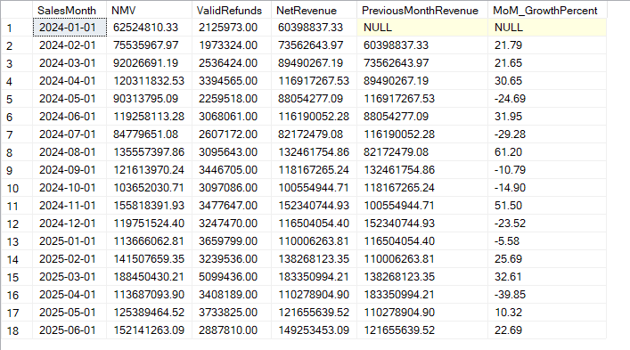
Note: January 2024 has no previous-month comparison in the available query output, so its MoM growth is NULL.

Q04. What are the overall return and cancellation rates, and how do they change over time?

Finding
Monthly cancellation rates ranged from 7.47% to 10.88% across January 2024–June 2025. The highest rate occurred in April 2025 (10.88%), while January 2024 had the lowest rate (7.47%).
Monthly return rates ranged from 3.93% to 5.69%. January 2024 had the highest observed return rate (5.69%), while June 2025 had the lowest (3.93%).

Interpretation
Cancellation rates increased notably in April 2025 and remained relatively elevated in May and June 2025. Return rates were comparatively stable around 5% for most months before falling to 3.93% in June 2025. These patterns identify months for further investigation, but do not establish the causes of the changes.

Recommendation
Investigate the April 2025 cancellation increase by examining order status, payment method, seller performance, and delivery conditions. Review the June 2025 return-rate decline to determine whether it reflects genuine improvement, incomplete return reporting, or a timing effect.

Method
Cancellation rate was calculated as distinct cancelled orders divided by all distinct orders in each month. Return rate was calculated as valid returned lines divided by delivered lines, where delivered lines are non-cancelled lines whose order is not marked In Transit.

Evidence and limitation
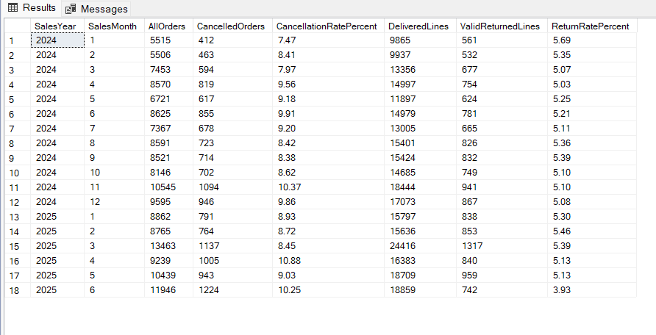
Attach the SSMS monthly return and cancellation results screenshot. These are warehouse-based results and depend on the correctness of the current cancellation, return, and order-status fields. The query's monthly grouping uses the fact table's order date, so returns recorded later than the original order month may not be attributed to the month the return occurred.

Q05. How does net revenue after returns and cancellations differ from gross revenue by category?

Finding
Electronics recorded the highest gross sales in the category analysis, at PKR 838.02 million, followed by Fashion at PKR 448.53 million. Electronics also had the highest net revenue, at PKR 73.50 million, while Fashion generated PKR 37.84 million in net revenue.
For Electronics, the query calculated a gross-to-net difference of PKR 102.97 million. This difference reflects the effects of discounts, cancellations, and refunds under the query's calculation; it should not be interpreted as refunds alone.

Interpretation
Gross sales represent sales before discounts and cancellations, while NMV excludes cancelled order lines and reflects discounts. Net revenue further subtracts valid, non-rejected refunds. The comparison shows why gross sales alone do not represent the revenue retained after these adjustments.

Recommendation
Use NMV and net revenue alongside gross sales when comparing categories. Investigate discount levels, cancellations, and valid refunds in high-volume categories to understand the factors reducing revenue. Review margin as well before making decisions about category profitability.

Method
The analysis grouped FactSales by product category and compared gross sales, NMV, valid refunds, net revenue, and the gross-to-net difference. The warehouse's gross, discount, and net amount fields were checked: the recalculated NMV was PKR 2,287,603,070.73, matching stored NetAmount with a difference of PKR 0.00.

Data-quality note
The output includes a NULL product category associated with the warehouse's Unknown product member. These records remain unclassified until their product references can be verified. Category-level figures should therefore be interpreted with this limitation in mind.

Evidence
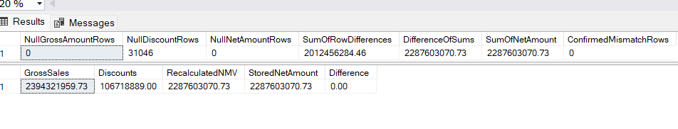
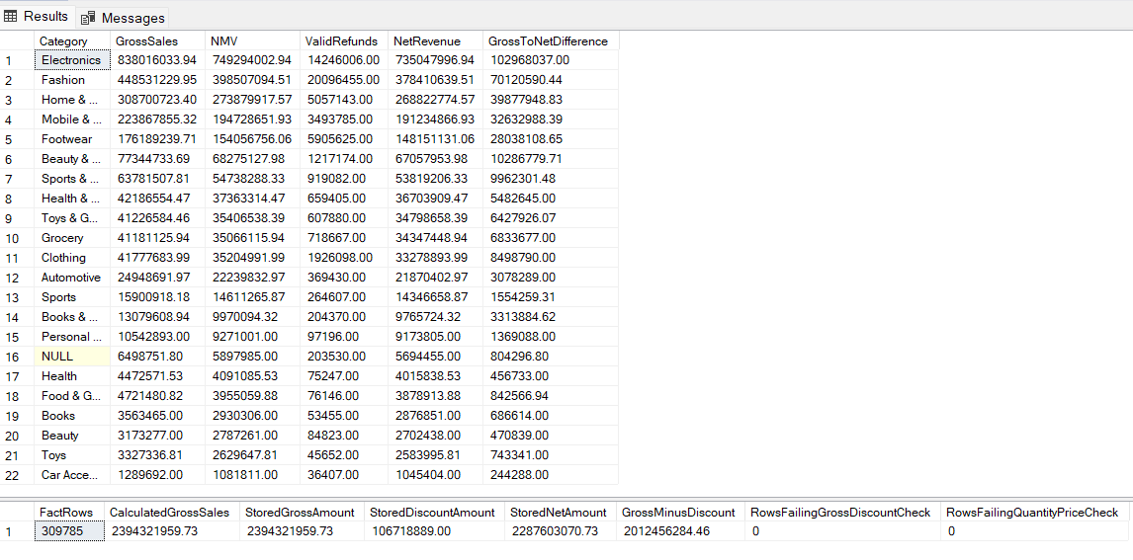

Q06. What is observed customer lifetime value, and how does repeat purchasing differ by region or category?

Finding
Across the available warehouse data, 33,340 customers had identifiable customer records and sales activity. Total observed net revenue was approximately PKR 2.06 billion, giving an average observed customer value of PKR 61,708.82.
A total of 22,796 customers made at least two distinct non-cancelled orders, resulting in an overall repeat purchase rate of 68.37%.
The regional activity analysis showed the following repeat purchase rates:
- Central: 53.54% across 19,387 customers.
- South: 50.11% across 13,362 customers.
- North: 46.92% across 8,759 customers.
- Unknown region: 14.33% across 5,137 customers.
Central had the highest repeat purchase rate among the named regions, followed by South and North. The Unknown region group has a substantially lower rate and should be investigated before drawing conclusions about customer behaviour there.

Interpretation
The results suggest that repeat purchasing is common in the overall customer population, with some differences across named regions. The average observed customer value represents historical revenue over the available data period; it is not a prediction of future customer spending.

Recommendation
Prioritize customer retention campaigns for existing customers, especially those with repeat-purchase potential. Investigate the Unknown region records before making regional targeting decisions, and use RFM segmentation to distinguish high-value repeat customers from customers who may need re-engagement.

Method
Observed customer value was calculated using non-cancelled sales after refunds in the available warehouse data. A repeat customer was defined as one with at least two distinct non-cancelled orders. The regional comparison grouped customer activity by the region associated with fact records.

Evidence and limitation
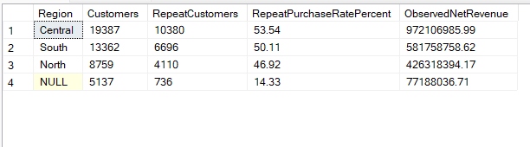

Q07. Which RFM segment generates the most revenue, and how large is it?

Finding
The Champions segment generated the highest observed revenue, at approximately PKR 101.74 million, across 5,062 customers. Its average observed customer value was approximately PKR 20,099.27.
Loyal Customers formed the largest segment by customer count, with 11,919 customers generating approximately PKR 69.83 million. Other Customers included 7,001 customers and generated approximately PKR 22.22 million. The At Risk and Recent Customers segments generated approximately PKR 8.06 million and PKR 3.88 million, respectively.

Interpretation
Champions generate the most revenue despite representing fewer customers than the Loyal Customers segment. This makes them an important group for retention and loyalty initiatives. The larger Loyal Customers segment also presents an opportunity to encourage more frequent purchasing and increase customer value.

Recommendation
Prioritize retaining Champions through relevant loyalty benefits and personalized offers. Develop targeted campaigns to increase purchase frequency among Loyal Customers, and use re-engagement campaigns for the At Risk segment.

Method
Customers were grouped using Recency, Frequency, and Monetary value (RFM). Recency was measured in days since the last purchase, Frequency as distinct non-cancelled orders, and Monetary value as observed net revenue after refunds. Three-band scores were used to assign customers to the documented RFM segments.

Evidence and limitation
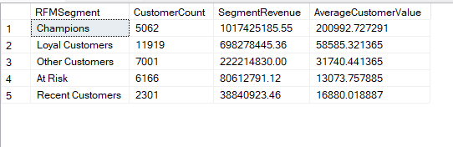

Q08. Seller Performance — How would you rank sellers using a justified quality score?

Answer:
The seller performance query compared sellers using order volume, net revenue, return rate, cancellation rate, and the available on-time delivery metric.
Based on the results, Zam Zam Solutions (S0351) recorded the highest net revenue among the displayed sellers, at PKR 119,165,423.07, across 3,561 orders. Its return rate was 3.72% and cancellation rate was 9.27%. Prime Bazaar (S0044) generated PKR 69,416,569.76 from 1,259 orders, with a 3.21% return rate and 10.48% cancellation rate. Pak Collection (S0293) generated PKR 56,384,627.00 from 626 orders, with a 4.87% return rate and 7.19% cancellation rate.
These results show that seller performance should not be judged by revenue alone. Zam Zam Solutions has the highest revenue among the displayed rows, while Prime Bazaar has a lower return rate and Pak Collection has a lower cancellation rate than both. A balanced ranking should consider all these factors.
A provisional quality score can assign 50% weight to revenue, 25% to return rate, and 25% to cancellation rate. After normalizing the metrics, higher revenue and lower return and cancellation rates should improve a seller’s score.
Limitation: The displayed query reports on-time rates, but the validation results show that only 848 of 278,863 eligible fact rows contain ShippingDays, and all 848 have a value of zero. The source shipping-date validation also returned zero parseable shipped or delivered dates. Therefore, the on-time rate cannot be trusted, and the final seller ranking should remain provisional until delivery data is corrected. The examples above are the first rows shown in the query output, not a confirmed ranking of every seller by the proposed quality score.
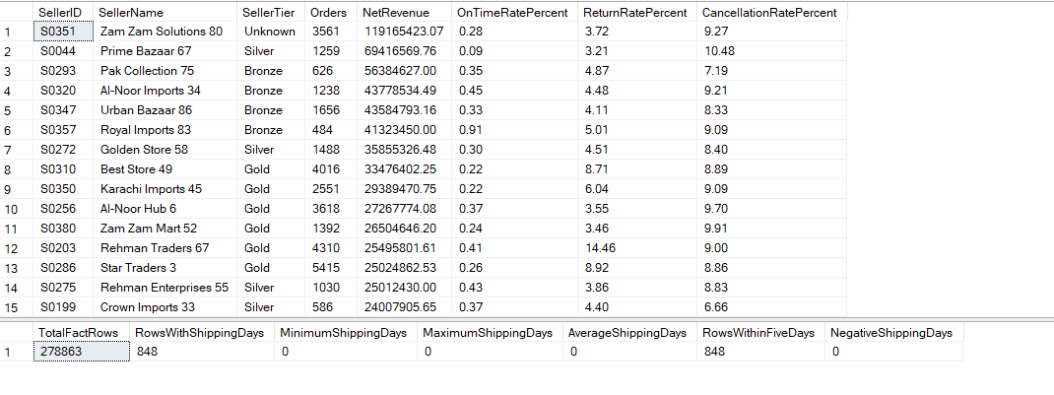

Q09. Delivery Performance — Are on-time deliveries associated with higher or lower return and cancellation rates?

Answer:
The analysis grouped orders by delivery duration and compared their return and cancellation rates.
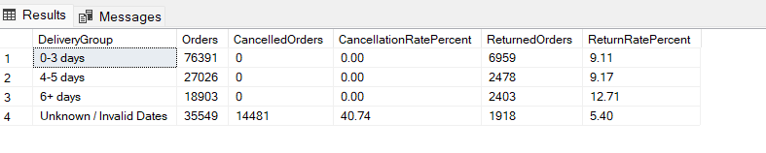
The return rate was highest among orders taking 6 or more days (12.71%), compared with 9.11% for orders delivered within 0–3 days and 9.17% for orders delivered within 4–5 days. This suggests that longer delivery duration may be associated with a higher return rate.
Limitation: The query reported zero cancellations in all three groups with valid delivery durations, while the unknown/invalid-date group had 14,481 cancelled orders. This pattern requires caution because delivery dates may be missing for cancelled or otherwise incomplete orders. Furthermore, delivery duration is not necessarily the same as meeting a promised delivery date. The results show an association in return rates, but they do not establish that slower delivery causes returns or that these orders were delivered on time.
Recommendation: Improve shipping-date completeness and compare return and cancellation rates using validated delivery records and a defined promised-delivery target.

Q10. Product Quality — Which products have high sales and high return rates, and which sellers are associated with them?

Answer:
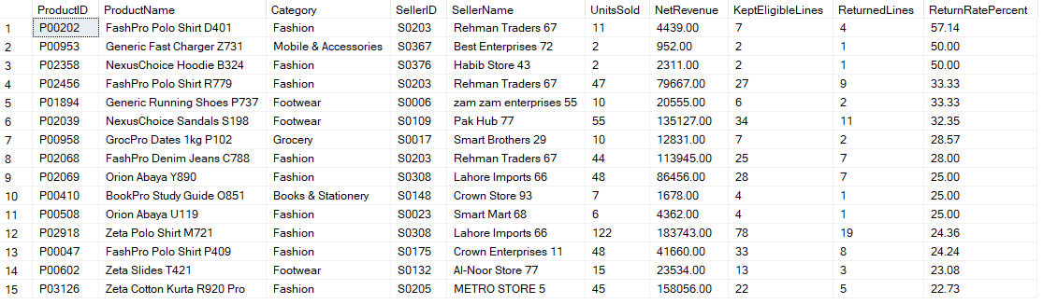
The analysis identified several product–seller combinations with elevated return rates. Among the displayed results, FashPro Polo Shirt D401, sold by Rehman Traders 67 (S0203), had a return rate of 57.14%, with 4 returned lines out of 7 eligible lines. Generic Fast Charger Z731, sold by Best Enterprises 72 (S0367), had a 50.00% return rate, with 1 returned line out of 2 eligible lines. NexusChoice Hoodie B324, sold by Habib Store 43 (S0376), also had a 50.00% return rate, with 1 returned line out of 2 eligible lines.
Other notable results include FashPro Polo Shirt R779, associated with Rehman Traders 67, which recorded 9 returned lines out of 27 eligible lines (33.33%), and NexusChoice Sandals S198, associated with Pak Hub 77, which recorded 11 returned lines out of 34 eligible lines (32.35%).
These findings highlight products and sellers that may warrant further quality checks, particularly within the Fashion category, which appears frequently among the highest-return combinations.
Limitation: The results are ranked by return rate, not by sales volume. Some products have very few eligible lines, making their percentages unstable. For example, a product with 1 return out of 2 eligible lines has a 50% return rate but limited evidence of a persistent quality issue. These results identify candidates for investigation; they do not prove that the product or seller caused the returns.
Recommendation: Investigate products with both substantial sales and consistently elevated return rates, and review their return reasons before deciding whether supplier quality, product descriptions, or other factors require corrective action.

Q11. Seasonality — Do Ramadan, Eid, 11.11, Black Friday, or Independence Day show sales spikes or higher return/cancellation rates?

Answer:
The analysis compared orders, net merchandise value (NMV), cancellation rates, and return rates across seasonal and promotional events.
- Ramadan recorded the highest NMV among the named events at approximately PKR 302.83 million, across 22,826 orders. Its cancellation rate was 8.39% and return rate was 5.26%.
- Eid-ul-Adha generated approximately PKR 271.13 million in NMV from 1,838 orders, with an 11.59% cancellation rate and 5.40% return rate.
- Eid-ul-Fitr recorded approximately PKR 234.55 million in NMV from 1,585 orders. It had the highest cancellation rate among the listed events at 13.00%.
- Singles Day (11.11) generated approximately PKR 13.12 million in NMV, with an 8.59% cancellation rate and 4.95% return rate.
- Black Friday generated approximately PKR 9.31 million in NMV, with an 8.36% cancellation rate and 5.33% return rate.
- Independence Day generated approximately PKR 3.87 million in NMV, with an 8.52% cancellation rate and 5.32% return rate.
Regular days recorded approximately PKR 1.74 billion in NMV, a 9.24% cancellation rate, and a 5.12% return rate.
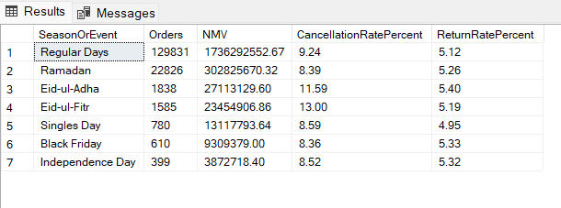
Conclusion: Ramadan and Eid periods contributed substantial sales, while Eid-ul-Fitr had the highest observed cancellation rate. Singles Day and Black Friday had lower observed NMV than the major religious periods.
Limitation: These figures describe the recorded event dates, but do not by themselves prove that an event caused a sales spike. Event duration and order volume differ, and the analysis does not compare each event with an equivalent non-event period. The results should therefore be interpreted as descriptive comparisons rather than causal evidence.

Q12. Discounts — Do discounts increase revenue while reducing margin or increasing returns?

Answer:
The analysis compared discounted and non-discounted orders using gross sales, discounts, NMV, net revenue, return rate, and cancellation rate.
Discounted orders had a slightly higher return rate (5.21% versus 5.06%) and cancellation rate (9.34% versus 9.10%). The discounted group recorded PKR 106.72 million in discounts, reducing the value retained after discounts compared with gross sales.
However, the non-discounted group had substantially more orders and higher total NMV and net revenue. These totals alone cannot establish whether discounts increased sales, because the groups differ in size and may differ in product mix and customer behavior.
Limitation: The query’s KeptLineCOGS measure does not by itself establish margin accurately, and total revenue comparisons are not normalized for order volume. Therefore, the results show a small association between discounts and higher return/cancellation rates, but do not prove that discounts caused those outcomes or improved sales.
Recommendation: Evaluate discounts using average order value, revenue and margin per order, and return/cancellation rates within comparable products or categories before expanding discount campaigns.

Q13. Delivery Times — Do regions with slower shipping experience higher cancellation or return rates?

Answer:
The regional analysis compared average delivery duration, invalid shipping-date records, cancellation rates, and return rates.
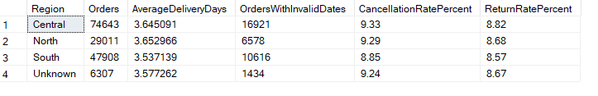
Central had the longest reported average delivery duration (approximately 3.65 days), along with the highest cancellation rate (9.33%) and return rate (8.82%). South had the shortest average delivery duration (approximately 3.54 days) and the lowest cancellation rate (8.85%) and return rate (8.57%).
These results suggest that Central has slightly higher delivery duration and order-problem rates than South. However, the differences are modest, so the results do not establish a strong relationship between delivery speed and cancellations or returns.
Limitation: Many orders have missing or invalid shipping dates, including 16,921 orders in Central. Regional averages are therefore based on incomplete delivery records and may not represent all orders. The analysis shows an association, not causation, and cannot establish whether deliveries met promised dates.

Q14. Payment Methods — Are certain payment methods associated with more cancellations or returns, and could data quality explain the differences?

Answer:
The analysis compared cancellation and return rates across payment methods.
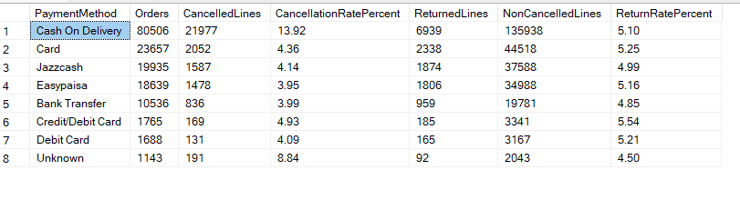
- Cash on Delivery (COD) had the highest cancellation rate at 13.92%, across 80,506 orders, with 21,977 cancelled lines reported by the query.
- Unknown payment method had an 8.84% cancellation rate, but covered only 1,143 orders.
- Credit/Debit Card had a 4.93% cancellation rate and the highest return rate among the named methods at 5.54%, although its order volume was much lower at 1,765 orders.
- Card had a 4.36% cancellation rate and a 5.25% return rate across 23,657 orders.
- Jazzcash had a 4.14% cancellation rate and a 4.99% return rate across 19,935 orders.
- Easypaisa had a 3.95% cancellation rate and a 5.16% return rate across 18,639 orders.
- Bank Transfer had a 3.99% cancellation rate and a 4.85% return rate across 10,536 orders.
Conclusion: COD is associated with a substantially higher cancellation rate than the other listed payment methods. Return rates, however, are relatively close across payment methods, ranging from 4.85% for Bank Transfer to 5.54% for Credit/Debit Card among the named methods.
Data-quality consideration: The results contain multiple similar labels, including Card, Credit/Debit Card, and Debit Card. These may represent different payment categories or inconsistent naming and should be verified before combining them. The Unknown category should also be retained and investigated rather than silently discarded.
Limitation: These are associations, not proof that payment method causes cancellations. Differences may also reflect customer behavior, order characteristics, or data quality. The query output labels CancelledLines even though its calculation sums cancellation flags at fact-row level, so this should not be interpreted as a distinct count of cancelled orders.

Q15. Overall Profitability — What factors explain flat profitability despite growing revenue, and what three actions should NexusMart take?

Answer:
The monthly analysis shows that NMV and net revenue generally increased over the analysis period, but margin on kept lines fluctuated considerably.
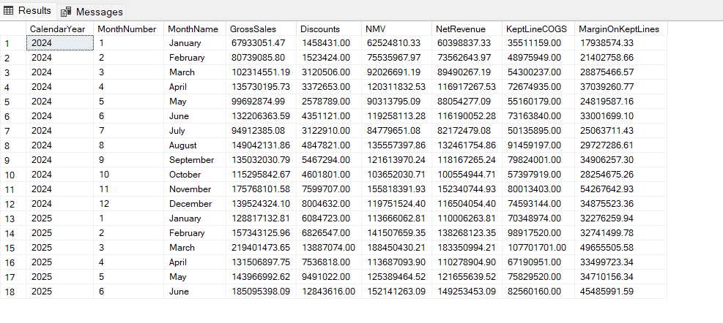
For example, monthly NMV increased from approximately PKR 62.52 million in January 2024 to PKR 152.14 million in June 2025. Net revenue increased from approximately PKR 60.40 million to PKR 149.25 million over the same period.
However, margin on kept lines did not increase consistently. It was approximately PKR 17.94 million in January 2024, rose to PKR 54.28 million in November 2024, and reached approximately PKR 49.66 million in March 2025 before declining to PKR 33.50 million in April 2025 and recovering to PKR 45.49 million in June 2025.
Several factors may explain why profitability does not consistently follow revenue growth:
- Discounting: The dataset records approximately PKR 106.72 million in discounts, reducing merchandise value before returns and costs are considered.
- Returns and cancellations: Refunds and cancelled orders reduce realized revenue, while returned or cancelled lines affect which costs and revenues are retained.
- Product and seller differences: Categories, products, and sellers can have different cost structures and return rates, so higher sales do not necessarily mean higher margins.
- Operational and data-quality issues: Incomplete shipping dates and unknown product or location records limit the ability to fully evaluate delivery-related costs and performance.

Three recommended actions:
- Optimize discount campaigns: Evaluate discounts using margin per order and comparable product/category performance, rather than sales volume alone.
- Reduce avoidable returns and cancellations: Investigate products with high return rates and the high cancellation rate associated with Cash on Delivery, then test targeted improvements.
- Improve operational and data quality: Correct shipping-date and missing-reference issues, and monitor revenue, kept-line margin, returns, and cancellations together in the dashboard.
Limitation: The monthly results show fluctuations in the calculated margin measure, but they do not independently prove which factor caused those fluctuations. The proposed explanations are hypotheses supported by patterns found in the other analyses and should be investigated further.

